**Cross Platform App Development Lab Experiment No. 1**

**Aim:** Designing user interface and wireframe for multiple layouts using Figma.

**Objectives:**

1. Understanding the concept of wireframing and its role in the design process.
2. To get an overview of Figma, its features, and its relevance in UI/UX design.

**Theory:**

* Wireframing is the initial step in creating user- friendly interfaces. Figma is a popular tool for this purpose due to its collaboration features and adaptability to different devices.
* About my mobile applications which is for customers and scrap dealer to easily report and track scrap materials.
* The scrap management app helps people who want to sell scrap and those who want to buy it to talk and make deals easily. It has features like creating accounts, showing what scrap is available.

**Requirements:**

1. Computer with internet access.
2. A Figma account.
3. Word processing software for creating the lab report.

**Tools:**

* **Figma:** Figma is a web-based design tool that allows users to create interactive user interface prototypes. It enables real-time collaboration and can be accessed from anywhere and on any device.

**Steps:-**

**Step 1:** Selecting design file

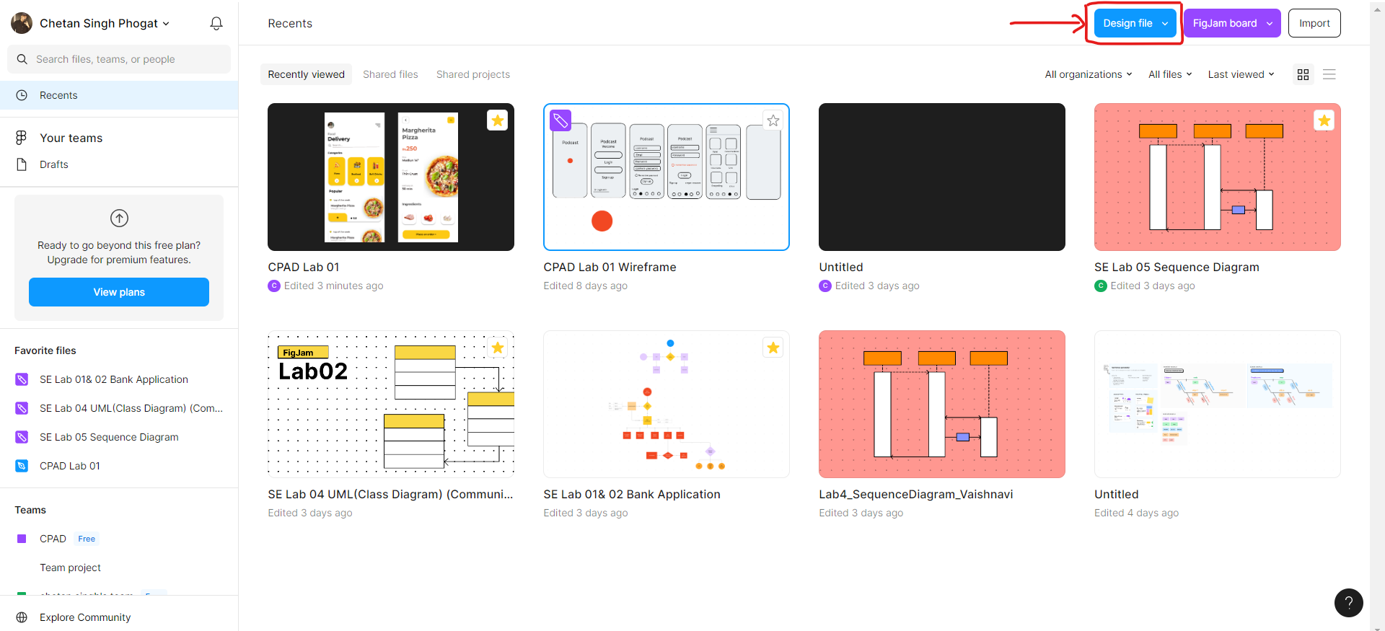

**Step 2:** Getting familiar with the UI of design file in Figma.

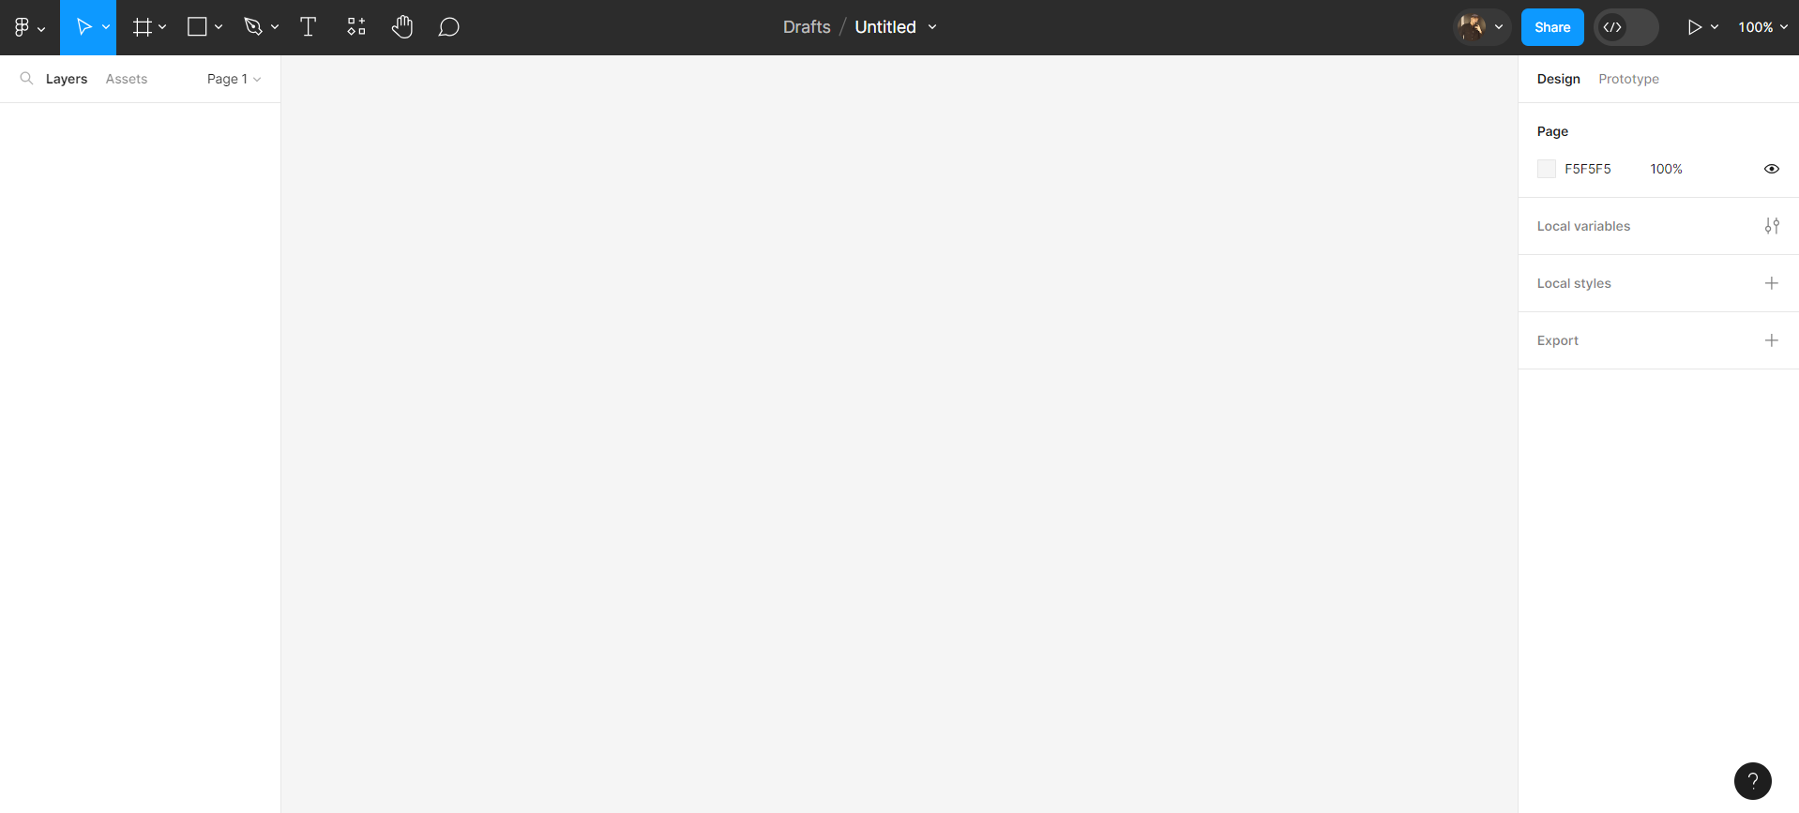

**Step 3:** Selecting frame for App

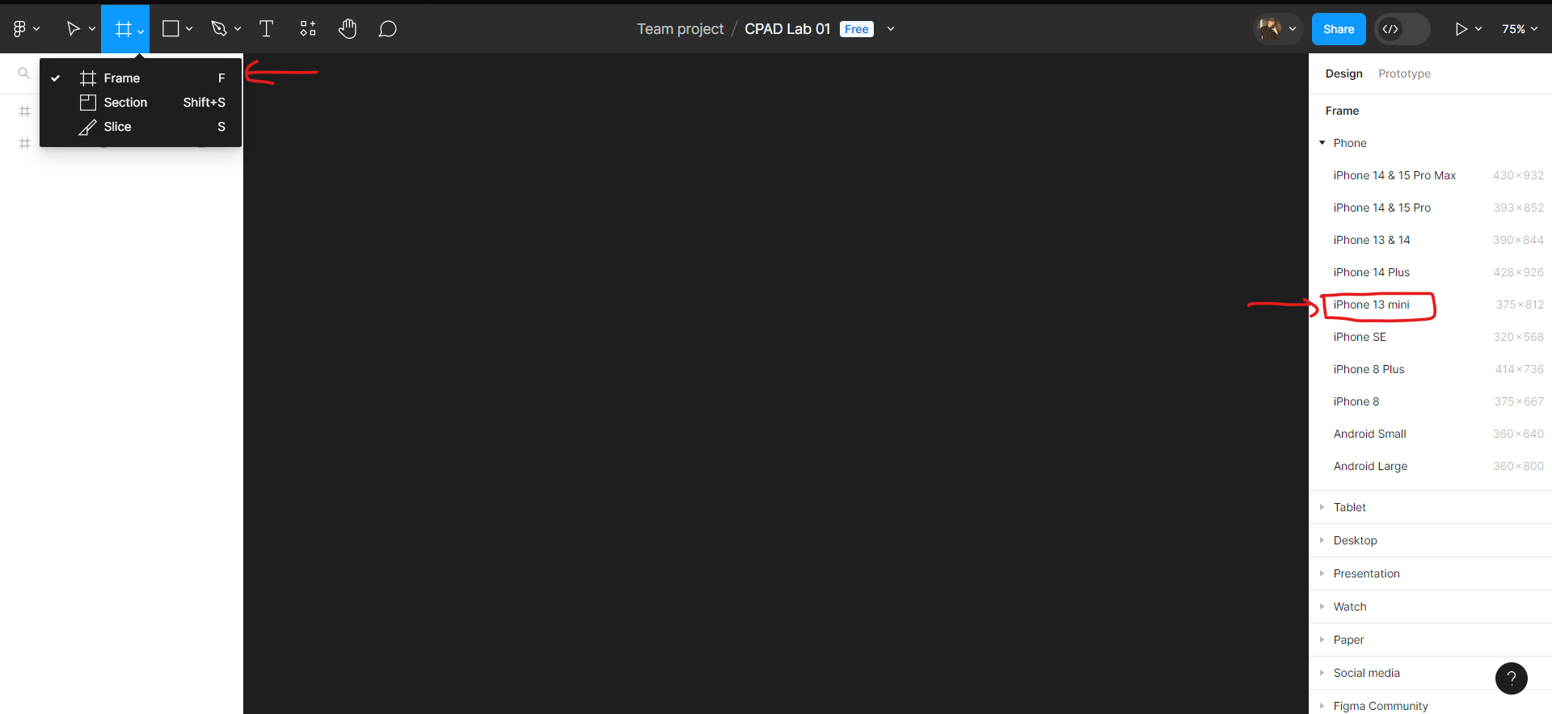

**Step 4:** Creating second layer of App

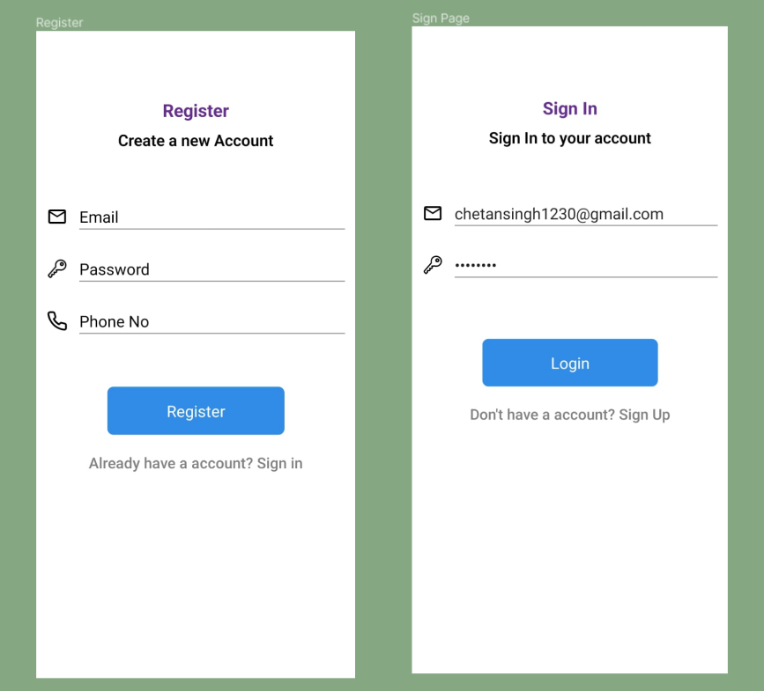

**Step 5:** Selecting icons for our UI frames.

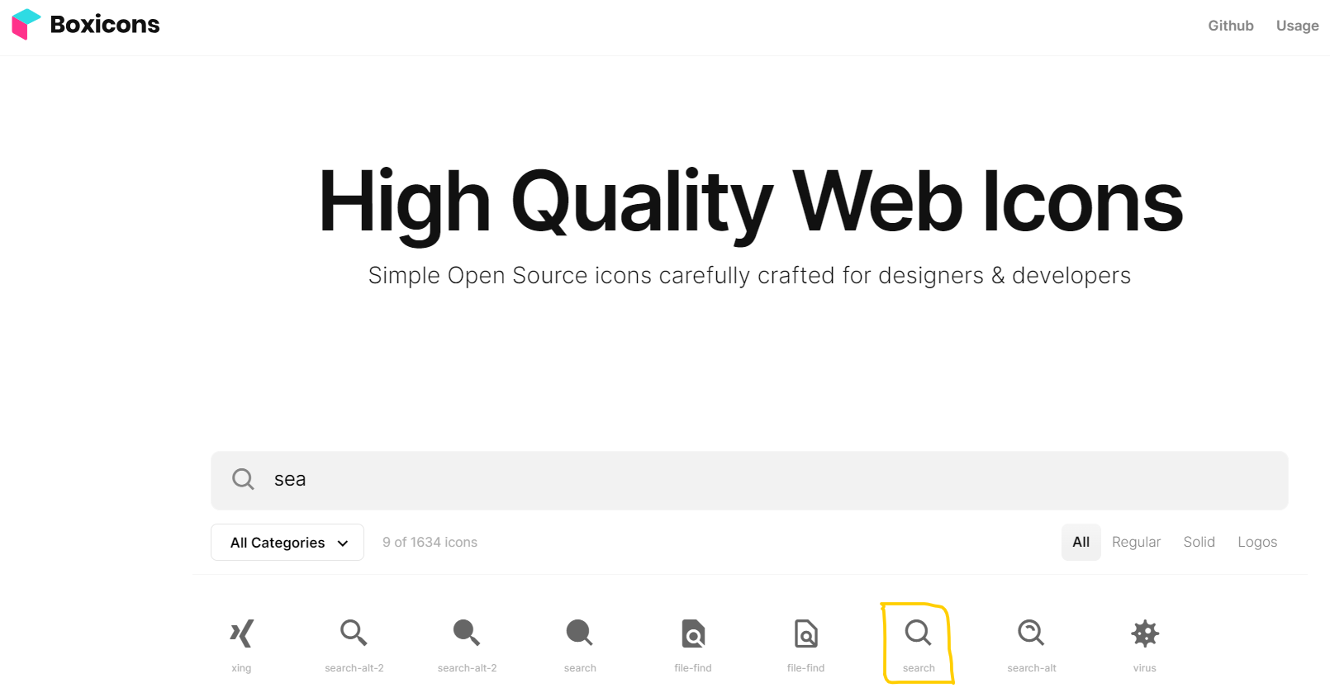

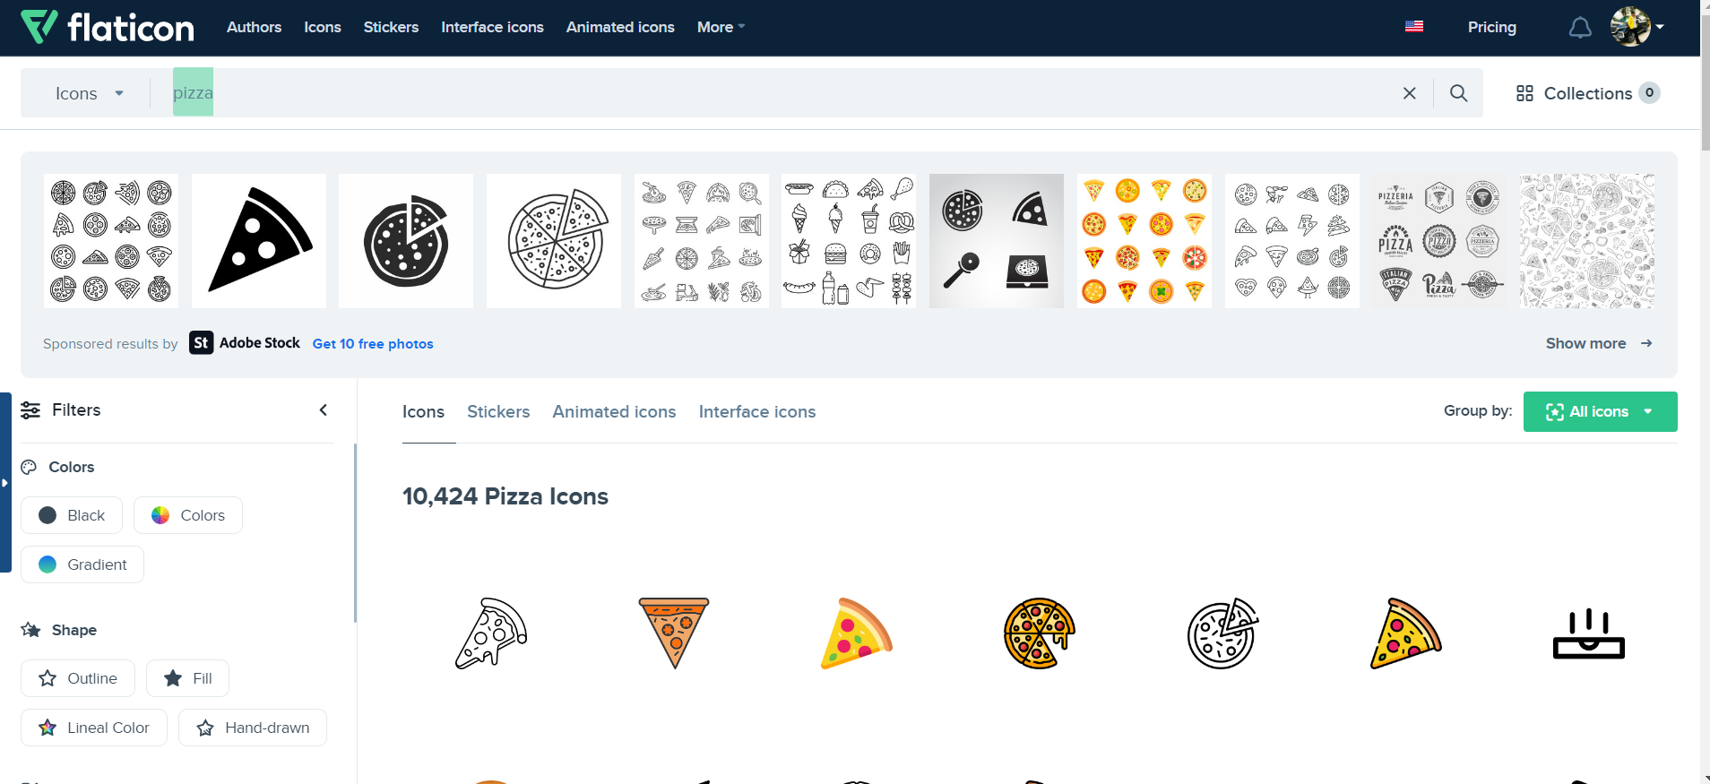

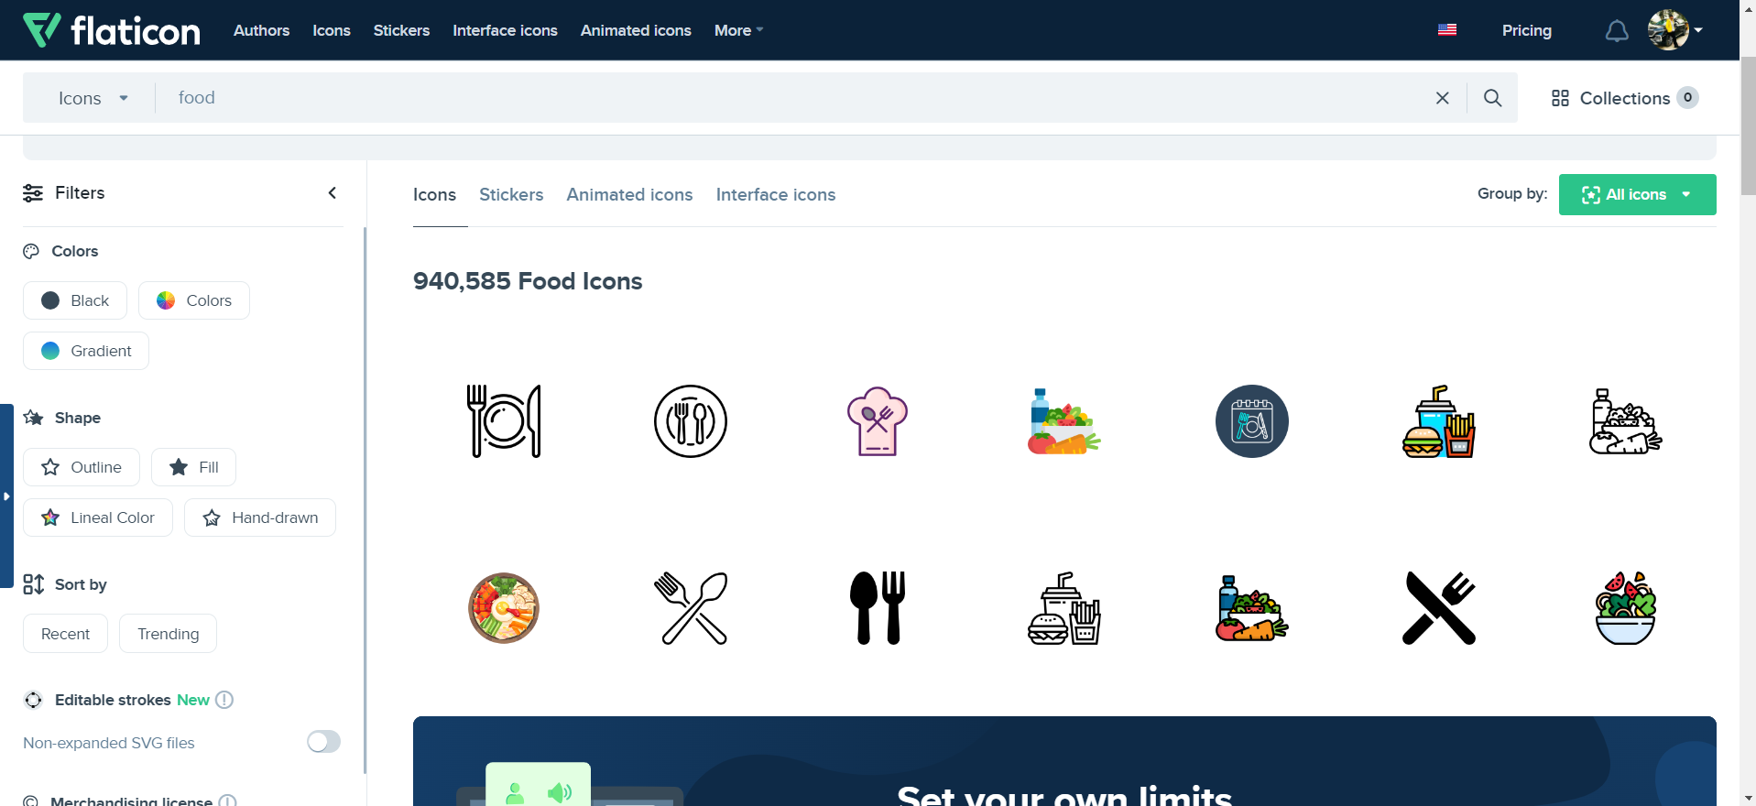

**Step 6:** Home page of Scrap Management App.

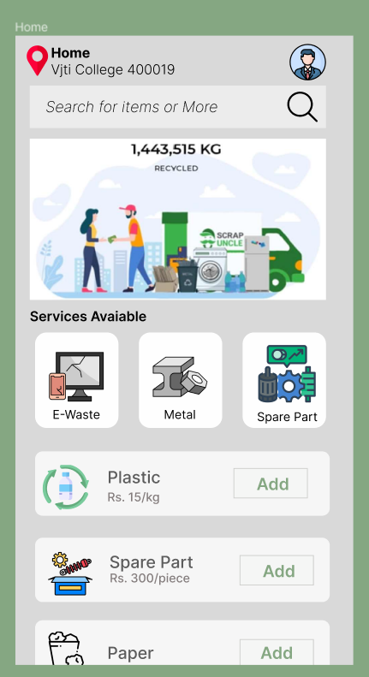

**Conclusion:**

Created wireframe and scrap management UI design using figma. This leads to the development of finely tuned, user-centric interfaces that effectively helps to the understand needs of both designers and end-users.

**References:**

1. Figma :- <https://www.figma.com/files/recents-and>

2. For UI Icons - <https://boxicons.com/>

- https://www.flaticon.com/search?word=pizza